Selenium IDE
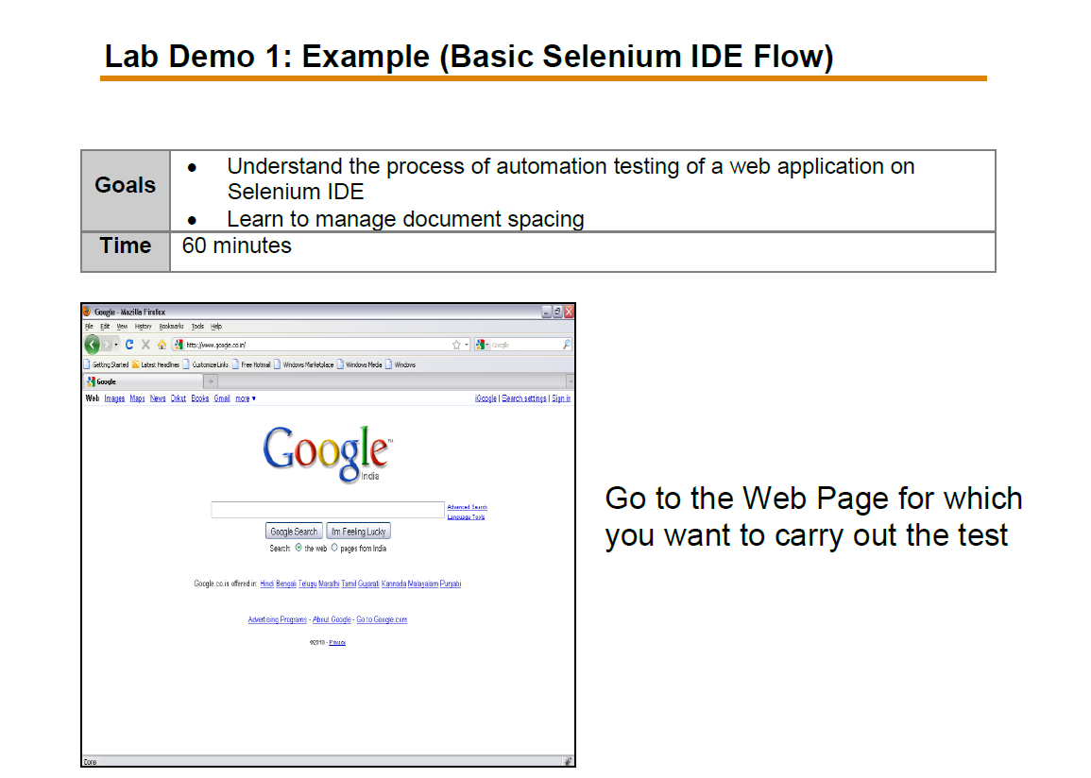

Step2:
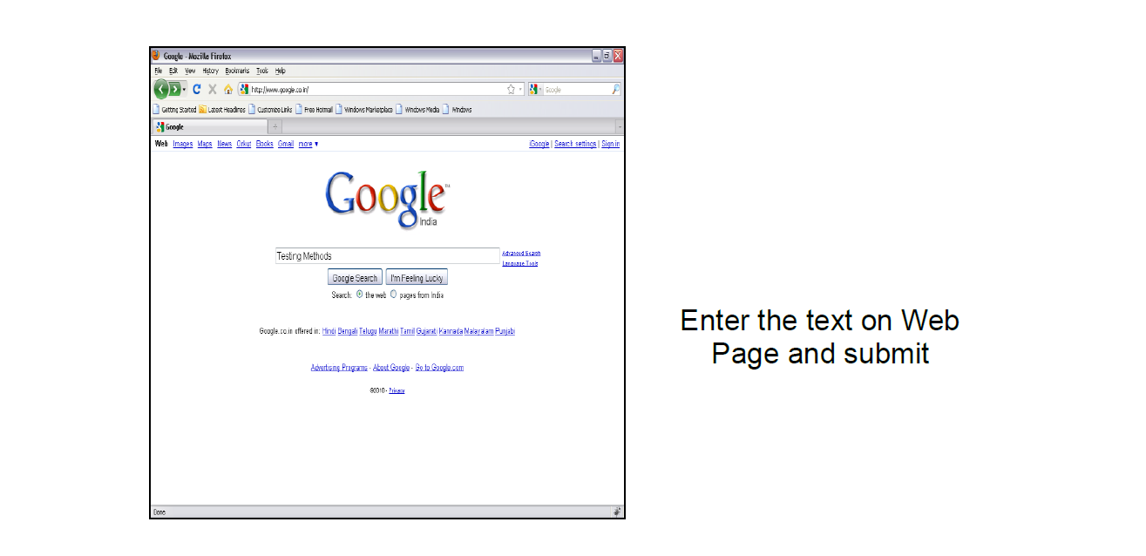

Step3:
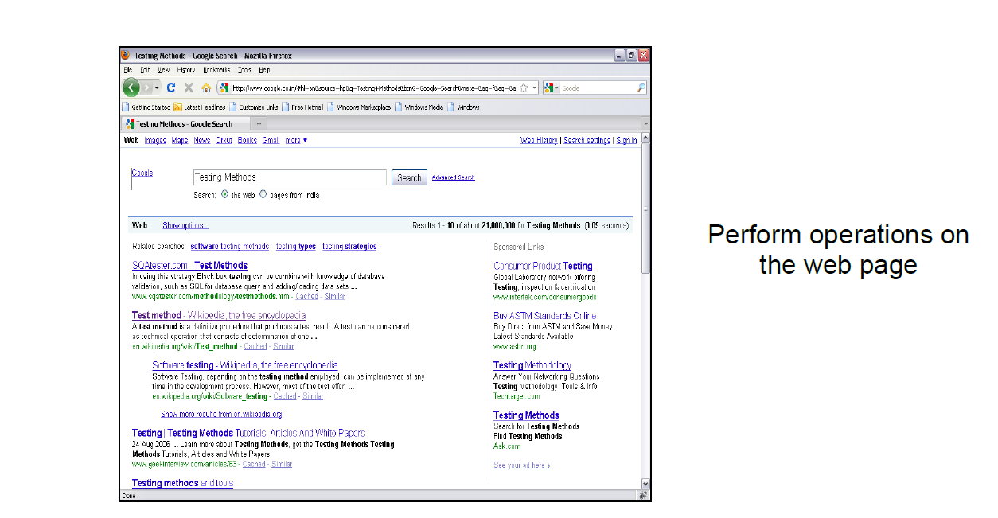

Step 4: Export as a Python Test Scripts and run and validate in Pycharm

